Sleep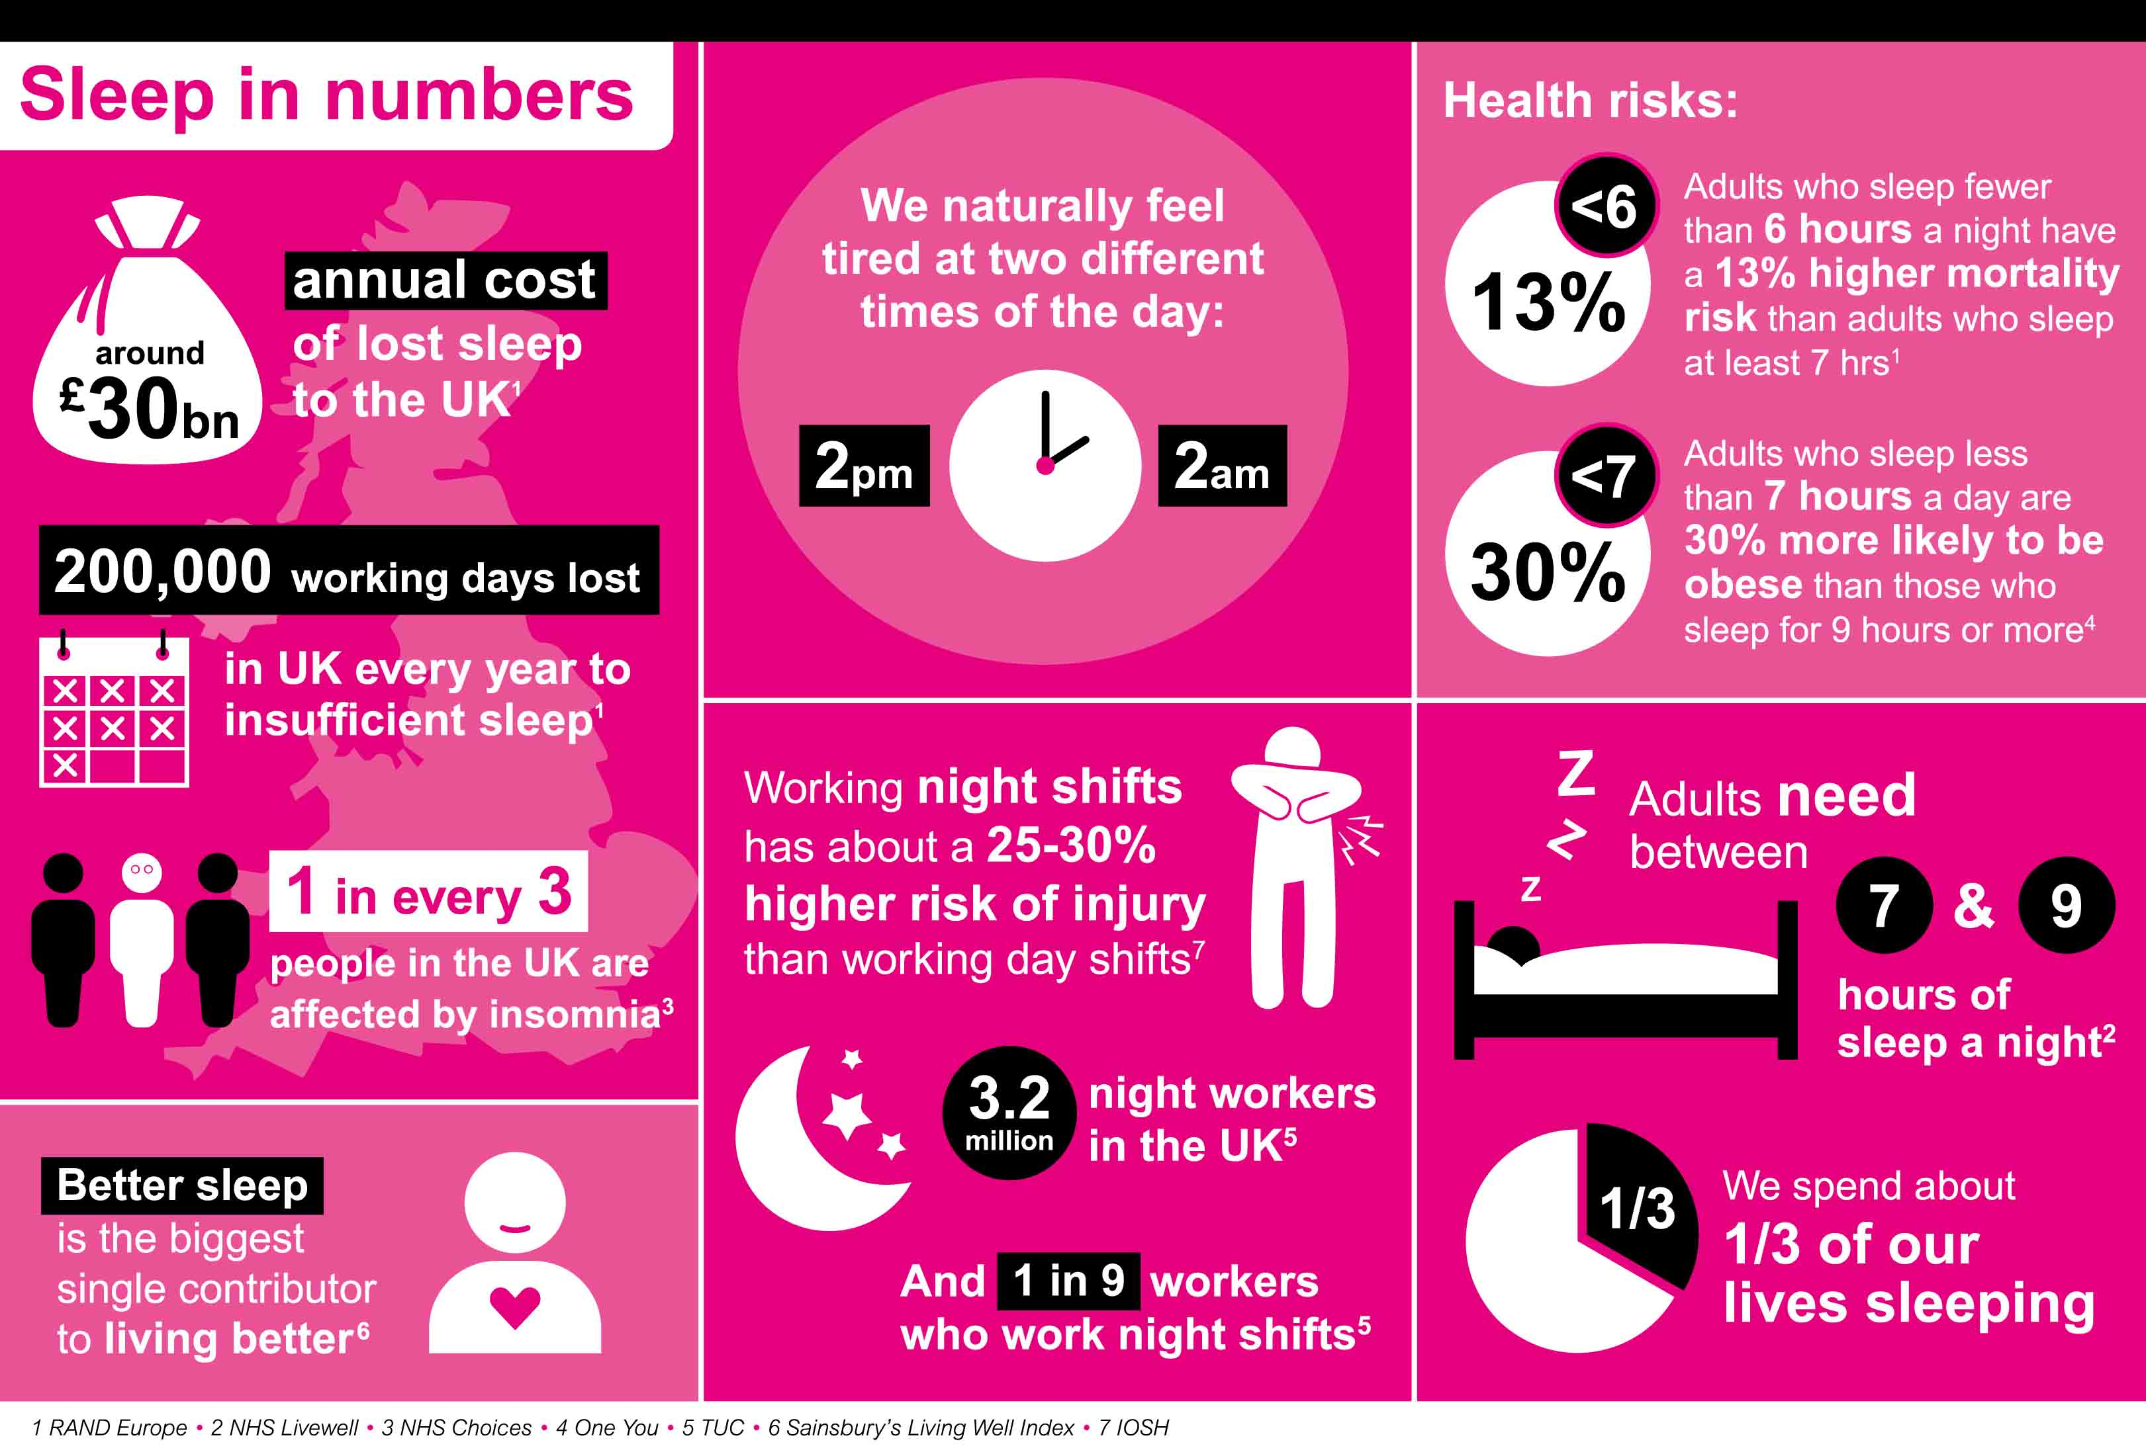
Sleep is as important to our health as eating, drinking and breathing. It allows our bodies to repair themselves and our brains to consolidate our memories and process information.
Poor sleep is linked to physical problems such as a weakened immune system and mental health problems such as anxiety and depression.
We all need to sleep well to help our bodies recover from the day and to allow healing to take place.
One in three of us suffers from poor sleep, and the consequences can be more serious than feeling grumpy or unfocused. Sleep and mental health are closely related: living with a mental health condition can affect your sleep, and poor sleep can affect your mental health.
Lack of sleep can also make us feel physically unwell. It’s linked to heart disease, diabetes, premature ageing and road accident deaths.
Sleep and mental health | Mental Health Foundation
What can cause sleep problems?
Many different things that can affect our sleep. They include:
- stress or worry
- a change in the noise level or temperature of your bedroom
- a different routine, for example because of jet lag
- too much caffeine or alcohol
- shift work
- physical or mental health problems
- side effects from medicines.

How can I improve my sleep?
There are many things you can try to help yourself sleep well.
- Establish a regular, relaxing bedtime routine that lets you unwind and sends a signal to your brain that it's time to sleep.
- Create a restful environment: bedrooms that are dark, cool and quiet are generally easier to fall asleep and stay asleep in.
- Try to go to sleep and wake up at the same time each day.
- Exercise regularly but avoid vigorous exercise near bedtime if it affects your sleep.
- Avoid caffeine and alcohol before bed. They can stop you falling asleep and prevent deep sleep.
- Only use your bed for sleep or sex. Unlike most physical activity, sex makes us sleepy.
- Try apps and online programmes designed to help with sleep problems such as Pzizz, Sleepio or Sleepstation.
- Avoid using screens in the evening, including on smartphones and tablets. The light from the screen can have a negative effect on sleep, and social media, news and games can all stimulate your brain and make you feel anxious.
- Write down your worries if you lie awake worrying about tomorrow. This can help put your mind at rest.
- If you can't sleep, don't worry about it. Get up and do something relaxing like listening to music or reading until you feel sleepy.

