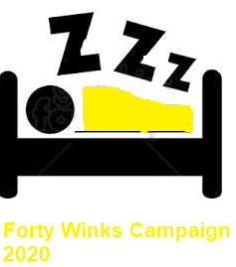
10 Sleep Apps Available

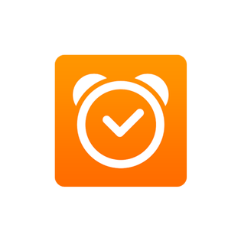
1. Sleep Cycle
Price: Free with optional in-app purchases

Sleep Cycle monitors your sleep patterns and offers detailed statistics and daily sleep graphs so you can get a better understanding of what’s going on when you hit the hay – or what may be interfering with a good night’s sleep. The app also features an intelligent alarm clock designed to gently wake you up when you’re in the lightest sleep phase.
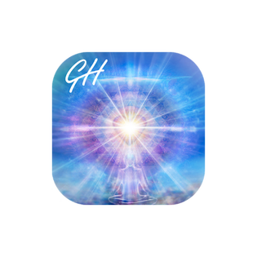

2. Relax & Sleep Well
Price: Free with optional in-app purchases
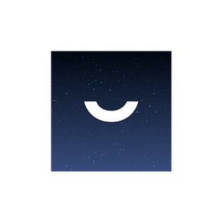
Glenn Harrold is an experienced hypnotherapist with more than 20 years of experience. His hypnosis and meditation app features four free hypnotherapy and meditation recordings and over 80 in-app purchases to address insomnia, stress, anxiety, sleep, and many more. Try the 29-minute hypnotherapy session designed to help you find profound feelings of relaxation and mindfulness to overcome insomnia.

3. Pzizz – Sleep, Nap, Focus
Price: Free with optional in-app purchases
Pzizz promises restful sleep without changing habits, keeping a sleep diary, or limiting your activities. The app’s patented system plays sleep-optimized “dreamscapes” that mix music, voiceovers, and sound effects. Try the nap module to boost alertness and improve your mood, or the “focuscapes” in the focus module to help you get more work done.

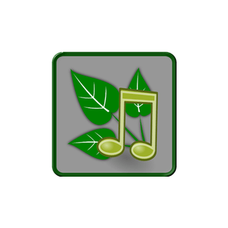
4. Nature Sounds Relax and Sleep
Price: Free with optional in-app purchases
Six nature-based relaxing tracks on this Android-only app will help you start your personal audio therapy. Choose from high-quality water sounds, nature sounds, animal sounds, white noise, and more, all designed to help you relax and sleep.
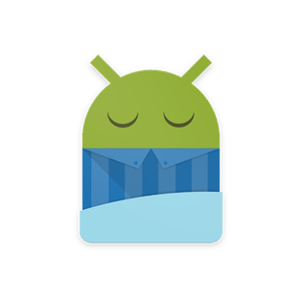

5. Sleep as Android
Price: Free with optional in-app purchases
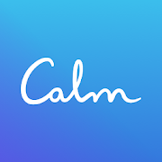
This Android app is designed to track your sleep cycle and measure its quality in terms of duration, deficit, deep sleep percentage, snoring, efficiency, and irregularity. These insights into your sleep patterns can help you make adjustments for a better night’s sleep. The app is compatible with multiple wearable devices, including Pebble, Wear OS, Galaxy Gear, Garmin, and Mi Band.

6. Calm – Meditation and Sleep
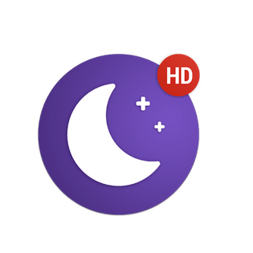
Calm is a leading app for meditation and sleep. Join the millions experiencing lower stress, less anxiety, and more restful sleep with our guided meditations, Sleep Stories, breathing programs, masterclasses, and relaxing music. Recommended by top psychologists, therapists, and mental health experts. Calm is the perfect mindfulness app for beginners, but also includes hundreds of programs for intermediate and advanced users

7. Sleepo
Price: Free with optional in-app purchases
Sleepo features a great collection of high-definition sounds that can be mixed into relaxing ambiances with a timer designed to automatically stop the app. Choose from 32 sounds in four groups — rain, nature, city, and meditation — plus three kinds of white noise, and start relaxing into sleep today.

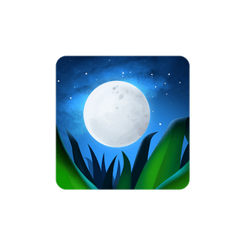
8. Relax Melodies: Sleep Sounds

Price: Free with optional in-app purchases
Choose sounds and melodies to customize and mix on Sleep Melodies to lull yourself to sleep, or try Sleep Moves. These sleep-inducing programs feature guided exercises with a pillow to help you enjoy restful sleep, and they’ve been approved by health and sleep professionals. The app’s five-day programs and single sessions can help you achieve deep sleep, better sleep, stress and anxiety relief, more effective napping, and more.
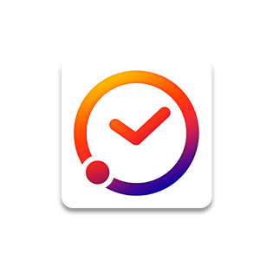

9. Sleep Time
Price: Free for iPhone, with optional in-app purchases.
Free with optional in-app purchases for Android
Learn to fall asleep quicker and wake up feeling refreshed by understanding your sleep cycles and sleep quality. The app includes soundscapes and white noise, 20 built-in alarms, sleep-cycle analysis, detailed monthly and weekly grabs, and an advanced wake-up optimization algorithm. Plus, the app’s full history and graphs make sleep comparisons easy.
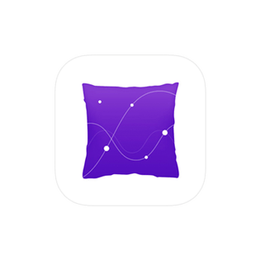

10. Pillow Automatic Sleep Tracker
Price: Free with optional in-app purchases
Pillow is a smart-sleep assistant for iPhone users. The app analyzes your sleep cycles automatically through your Apple Watch, or you can just keep your phone nearby when you sleep. Features include a smart alarm clock to wake you during the lightest sleep stage, sleep trend tracking, sleep aid sounds, and personalized insights and tips for better quality rest.

