Oral Health Quiz - Answers
Now you’ve completed the quiz, let’s see how much you knew about Oral Health and Sustainability!
- True or False? Poor dental health is linked to many serious diseases and conditions.
  - True
  - False

- What is the first sign of gum disease?

- Inflamed/Bleeding gums
- Loose teeth
- Bad breath
- Stained teeth
Gum disease is a very common condition where the gums become swollen, sore or infected. Most adults in the UK have gum disease to some degree, and most people experience it at least once! If you have gum disease, your gums may bleed when you brush your teeth. This early stage of gum disease is known as Gingivitis.

- The best way to prevent gum disease is to:

- Remove plaque
- Use fluoride toothpaste
- Use mouthwash
- Avoid sugary drinks
Gum disease is caused by a build-up of plaque on the teeth, which is a sticky substance made up of food and saliva that contains millions of bacteria. If plaque isn’t removed by brushing teeth twice a day, and regularly cleaning between teeth using dental floss or an interdental brush, it can build up and cause Gingivitis. If early signs of Gingivitis aren’t dealt with quickly, they can lead to Periodontitis, where the gums pull away from the teeth, which may then loosen or in worse cases could even fall out.

- Which of the following are linked to gum disease?

- Cardiovascular disease
- Stroke
- Diabetes
- All of the above
Some studies suggest that the bacteria in gum disease can travel to your heart and cause heart disease, clogged arteries or stroke. Gum infections, such as Periodontitis, have been linked to premature births and low-birth weight in pregnant women. Diabetes reduces the body’s resistance to infection, making the gums more susceptible to infection, which can adversely affect blood sugar.

- How often should you replace your toothbrush?

- 2-3 months
- 4-6 months
- 7-9 months
- 10-12 months
Most orthodontists and dentists recommend changing your toothbrush (or toothbrush head if you use an electric toothbrush) every 3 months, as fungus and bacteria can develop in your toothbrush, as well as the effectiveness being reduced by frayed bristles. You should also have regular check-ups with your dentist.

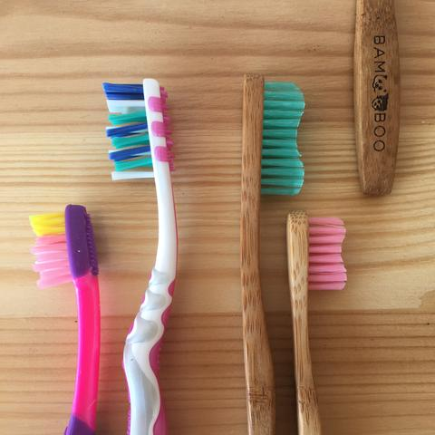
- How long does it take a plastic toothbrush to decompose?

- 50 years
- 100 years
- 250 years
- 400 years
Plastic toothbrushes take over 400 years to decompose! In comparison, a bamboo toothbrush only takes up to 3 years to decompose, and even quicker if disposed on a compost heap! In addition to this, bamboo is one of the fastest growing natural plants, thus a renewable and sustainable resource, whereas most standard toothbrushes are made from polypropylene plastic, which is derived directly from fossil fuels.

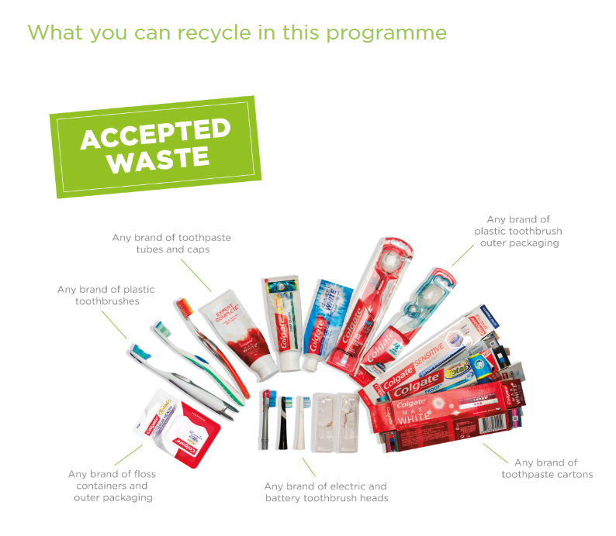
- How long does it take a plastic tube of toothpaste to decompose?

- 100 years
- 250 years
- 500 years
- 650 years
Toothpaste tubes are often made of different types of plastics, as well as containing an aluminium layer, which helps to keep the toothpaste tasting minty fresh! In general, toothpaste tubes are not recyclable and can take up to 500 years to decompose, although there has been a breakthrough by Colgate and Terracyle, who now offer a recycling scheme for oral care products!

- Approximately how many plastic toothbrushes are sent to landfill in the UK each year?

- 87 million
- 112 million
- 266 million
- 351 million
In 2019 the UK population was 66.65 million people, each using around 4 toothbrushes and tubes of toothpaste a year! This equates to approximately 266 million toothbrushes that went to landfill last year, the same weight as 28 female Blue Whales, the largest creature on earth, each weighing up to 190,000kg!
When lightweight plastic is transported to landfill, it can often be blown away and eventually clutter around drains or on beaches, easily making its way into the ocean. Once in the ocean, plastic decomposes very slowly, breaking down in to tiny pieces known as micro plastics that are eventually ingested by all kinds of sea life.


Maintaining your teeth isn’t only about looking good. Poor dental hygiene can lead to problems that are much bigger than an unpleasant smile. Tooth decay and gum disease can have a profoundly, negative affect on areas outside of the mouth, including your heart, diabetes, pregnancy and chronic inflammation, such as arthritis — to name a few.
Some studies suggest that the bacteria in gum disease can travel to your heart and cause heart disease, clogged arteries or stroke. Gum infections, such as periodontitis, have been linked to premature births and low-birth weight in pregnant women. Diabetes reduces the body’s resistance to infection, making the gums more susceptible to infection, which can adversely affect blood sugar.
Practicing good dental hygiene is so important, because it can prevent these types of oral disease and dental problems, and prevention should be the primary focus. You should see your dentist if you experience pain, bleeding gums, swelling, both inside and outside the mouth, tenderness, blisters and ulcers that don’t heal, or noticeable changes in colour or texture of the soft tissues. These could all be indications of a serious, or potentially serious condition, such as mouth cancer or chronic gum disease.
The key to good dental hygiene includes brushing for at least two minutes twice a day with a fluoride toothpaste, flossing daily and seeing your dentist every six months for check-ups and dental cleanings.
With routine visits to your dentist and good oral hygiene, your teeth should last a lifetime, as they were designed to do!
Instead of buying single use plastic toothbrushes and toothpaste in plastic tubes, how about having a look into more environmentally sustainable options, such as compostable bamboo toothbrushes, and toothpaste tablets that come in recyclable aluminium tins? There are more and more options becoming available, even from mainstream chemists such as Superdrug and Boots! See below some of the different companies who are dedicated to eliminating single use plastics from their products:

Georganics (UK based producer)
Eco-Living
Ben & Anna (available at Holland & Barrett)
The Humble Co. (available at Superdrug and Boots)
Waken (vegan-friendly mouthwash in fully recyclable aluminium bottles, available at Boots)

