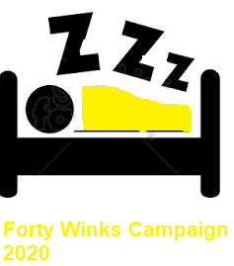
Does eating cheese before bedtime really give you nightmares?

Apologies before we start, but this is all going to sound a bit cheesy. Obviously, because it’s all about cheese and whether it does or doesn’t give us nightmares.

We didn’t take the subject too seriously at first and saw it as just one of those ‘sayings’ that people quote a lot yet don’t really believe. But when we did start to investigate, it seems there is a connection between cheese, dreams and nightmares. This is what we found about the effects of eating cheese before bed.

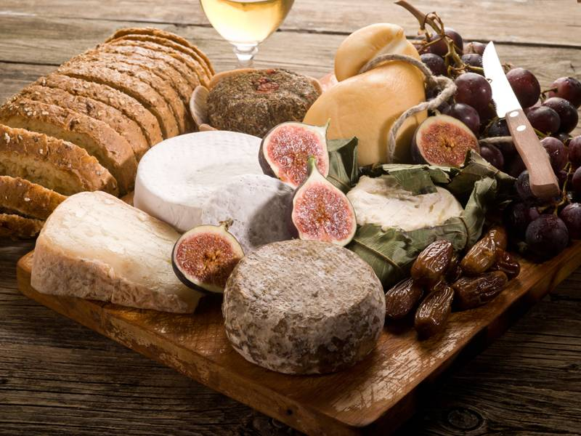

Stabilising sleep and reducing stress
In 2005 The British Cheese Board carried out a study in which a number of people were given a 3 ounce piece of cheese to eat just before bedtime. Different people were given different types of cheese and a report was then taken to record the dreams and nightmares of all the participants to detect any patterns.
Overall, the good news for the Cheese Board was that an impressive 75% of the participants said they slept pretty well each night, with no occurrence of nightmares. Additionally, most of them said that they could clearly remember their dreams. This led to the conclusion that the essential amino acid in milk, and therefore cheese – tryptophan – was having its effect on the cheese eaters by stabilising their sleep patterns and reducing stress levels.

Different cheeses produce different types of dreams

1. Cheddar Cheese
Cheddar cheese tended to produce dreams about celebrities, including sitting in a pub with Katie Price and playing football with Paul Gascoigne. Cast members from popular soaps like Coronation Street and Emmerdale also made appearances in cheddar induced dreams.

2. Red Leicester

Red Leicester caused nostalgic dreams often related to childhood.

3. Lancashire Cheese
Lancashire cheese produced dreams about work, which could arguably be termed a nightmare for some people.

4. Stilton Cheese
Stilton cheese produced the most vivid, unusual and downright strange dreams. These included talking soft toys, lifts that move sideways and soldiers fighting each other with kittens instead of guns. Not nightmares, but certainly very off the wall dreams. Stilton could be a great choice if you work in a creative environment and require some story fuel.

5. Cheshire Cheese

Cheshire cheese led to a peaceful, night’s sleep without any dreams at all. So, if you want a peaceful night’s sleep with no interruptions, this is the cheese for you.
No nightmares, but plenty of dreams
So does eating cheese before bedtime give you nightmares? No it doesn’t. Well at least according to research by The British Cheese Board it doesn’t. What it does seem to do though is produce a whole variety of different dreams that all seem to be fairly memorable. Which means if you’re one of those people who like to dream and really want to dream more often, then cheese for supper might just do the trick.
Let us know about any cheese related dreams you have. We won’t think you’re crackers, honest!

