Useful links
If you need to ask me anything or if you have any ideas on how we could raise awareness within your organisation etc., please email:
louise.parker@britishlivertrust.org.uk
General website: https://britishlivertrust.org.uk/
Admin team: 01425 481 320 Mon-Fri 9-5 info@britishlivertrust.org.uk
Liver cancer website- https://livercanceruk.org/
Nurse-led helpline- Mon- Fri 9am-3pm 0800 652 7330 (excluding bank holidays) helpline@britishlivertrust.org.uk
Awareness:
January is our Love your Liver month and October is Liver Cancer Awareness month YET anytime of the year is good to raise awareness.
I will share resources with Susanne closer to each campaign month.
The below resources could all be added to wellbeing files or posters could be placed on info boards etc. and some links could be shared in any newsletters or stored on any websites etc.
Awareness raising resources that can be ordered for just the cost of postage
https://britishlivertrust.org.uk/information-and-support/our-publications/individual-orders/
There are “questions about liver disease” wallet cards, there are tri-fold leaflets titled Are you at risk of liver disease? Leaflet and posters you can order too.
Our condition specific resources carry a cost, we encourage individuals who may be affected by a liver condition to head to our website to request a copy to be posted out or they can be downloaded for free.
Liver Cancer QR codes sheet for any wellbeing files:
https://livercanceruk.org/wp-content/uploads/2023/09/Liver-Cancer.pdf
Liver screener- online risk screener, you can do this now or use this QR code:
https://britishlivertrust.org.uk/risk/
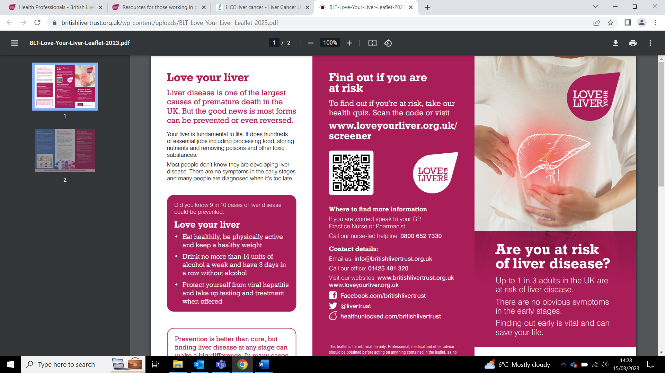
Roadshows- List of locations and dates will be added to this once confirmed, this is where people can complete our online liver screener & access a free Fibroscan:
https://britishlivertrust.org.uk/information-and-support/love-your-liver/roadshow/
Healthy eating tips-
https://britishlivertrust.org.uk/download-pdf/?title=Healthy+eating+tips&downloadurl=https%3A%2F%2Fbritishlivertrust.org.uk%2Fwp-content%2Fuploads%2FEating-more-healthily.pdf
Cutting down on alcohol:
https://britishlivertrust.org.uk/download-pdf/?title=Cutting+down+on+alcohol&downloadurl=https%3A%2F%2Fbritishlivertrust.org.uk%2Fwp-content%2Fuploads%2FCutting-down-on-alcohol.pdf
FREE Hepatitis C testing kit link:
https://britishlivertrust.org.uk/new-nhs-hepatitis-c-home-testing-scheme/

Support (poster attached in email)
Nurse-led helpline- Mon- Fri 9am-3pm 0800 652 7330 (excluding bank holidays) helpline@britishlivertrust.org.uk
https://britishlivertrust.org.uk/information-and-support/support-for-you/helpline-and-online-community/
Support & support groups- Support for people living with or caring for someone living with liver disease: https://britishlivertrust.org.uk/information-and-support/support-for-you/
Support group registration- https://britishlivertrust.org.uk/virtual-support-group-registration/
Health Unlocked- The social peer network for health conditions: https://healthunlocked.com/britishlivertrust
HE passport- https://britishlivertrust.org.uk/hepatic-encephalopathy-passport/
Patient charter-what care you should expect- https://britishlivertrust.org.uk/liver-disease-patient-charter
Questions to ask your doctor -https://britishlivertrust.org.uk/information-and-support/questions-to-ask-your-doctor/
Helpful information and resources, including other organisations who offer information or advice -Additional resources & information
Publications- A range of guides and factsheets for those affected by liver disease, individual copies can be requested by post for free or downloaded directly from our website: https://britishlivertrust.org.uk/information-and-support/our-publications/
Useful words glossary: https://britishlivertrust.org.uk/information-and-support/useful-words-glossary/
LIVEr North
https://www.livernorth.org.uk/
Children’s Liver Disease Foundation
https://childliverdisease.org/
Liver conditions & lifestyle
A to Z of liver conditions:
https://britishlivertrust.org.uk/information-and-support/liver-conditions/
Alcohol related liver disease: https://britishlivertrust.org.uk/information-and-support/liver-conditions/alcohol-related-liver-disease/
Non-alcohol related fatty liver disease-now called Metabolic dysfunction-associated steatotic liver disease (MASLD)
https://britishlivertrust.org.uk/information-and-support/liver-conditions/non-alcohol-related-fatty-liver-disease/
Viral hepatitis:
https://britishlivertrust.org.uk/information-and-support/liver-conditions/viralhepatitis/
Liver disease testing:
https://britishlivertrust.org.uk/information-and-support/tests-diagnosis-and-screening/
Booklet:
https://17xpvwx1p0y4h.cdn.shift8web.com/wp-content/uploads/LDTE-03_2019-web-version.pdf
Looking after yourself with liver disease- https://britishlivertrust.org.uk/information-and-support/living-with-a-liver-condition/living-with-liver-disease/looking-after-yourself-when-you-have-liver-disease/
Physical activity & exercise- https://britishlivertrust.org.uk/information-and-support/living-with-a-liver-condition/diet-and-liver-disease/physical-activity-exercise/
Diet- https://britishlivertrust.org.uk/information-and-support/living-with-a-liver-condition/diet-and-liver-disease/
Looking after your mental health-https://britishlivertrust.org.uk/information-and-support/mental-health-and-liver-disease/
Money- https://britishlivertrust.org.uk/information-and-support/living-with-a-liver-condition/money/
Patient stories & educational webinars- https://www.youtube.com/@BritishLiverTrust/videos
Campaigns:
Campaign for early diagnosis (write to your MP): https://britishlivertrust.org.uk/write-to-mp/
NEW CAMPAIGN- Liver scans in Community Diagnostic Centres – write to your MP
https://britishlivertrust.org.uk/write-to-mp-cdc/
January is Love your Liver month:
https://britishlivertrust.org.uk/love-your-liver-month/

Stamp out stigma:
https://britishlivertrust.org.uk/stigma/
Research:
https://britishlivertrust.org.uk/health-professionals/research-and-clinical-trials/
Video links from presentation:
Liver health stages short video (1min 34):
https://www.youtube.com/watch?v=zoMeLS_OBKE
Wendy’s story: (3min 32)
https://www.youtube.com/watch?v=-GHpK2Szshg
Let’s talk Liver Disease (3min 14)
https://britishlivertrust.org.uk/talking-about-liver-disease-risk-training-resource
Other:
Coffee and the liver: https://britishlivertrust.org.uk/drinking-coffee-reduce-liver-cancer-risk-suggests-study/
Supplements information
https://britishlivertrust.org.uk/information-and-support/living-with-a-liver-condition/supplements-and-vitamins/

Social media:
Facebook- https://www.facebook.com/britishlivertrust
Twitter- https://twitter.com/LiverTrust
Instagram- https://www.instagram.com/british_liver_trust/
YouTube- https://www.youtube.com/user/BritishLiverTrust
TIK TOK- https://www.tiktok.com/@britishlivertrust

