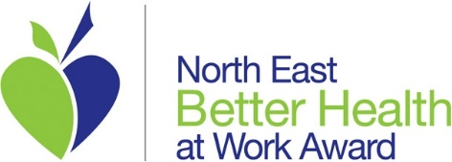

HEALTH CAMPAIGN PLAN
Name of Health Campaign | Sleep
Name(s) of Health Advocate Campaign Lead

Reason for Campaign | The 2019 health needs assessment survey highlighted over 47% of staff who have a problem with their sleep 4 or more days per week. The campaign, linked to National Sleep Awareness Week in March 2020, aims to provide staff with some tools and information to support them in their understanding of their sleep difficulties
Date(s) of Campaign | 8th - 13th March
Venue(s) for Campaign (where applicable) | All Team Fostering Offices
Scope of Campaign  Tick all relevant boxes | Staff | x
 | Foster Carers
 | Foster Children
 | Board Members
 | Sessional Staff
 | Others – list
Resources required
Outline staffing, financial, equipment, materials
Communication methods | Email, Posters, Talking to staff in offices, Team Talk
How will the campaign be evaluated? | Evaluation Sheets at the end of campaign sent to all staff

Health Campaign Project Timeline
List all key tasks for campaign

Task | Date | Who | Notes
Preparation of Forty Winks Campaign 2020 | By 5 March 2020 |  | Preparation of tools and information documents. Liaise with Casey Spence and Ashleigh Salter to develop HSW “campaign” area on TEAM TALK. Evaluation survey to be developed
Sleep Calculator | 9th March 2020 |  | Sleep calculator link sent out on the morning at 10am to send to all staff. Explaining why sleep is important, how to work out the ideal bedtime and what a sleep cycle is.
Stress Test | 10th March 2020 |  | Link sent for staff to complete a stress test, once this has been completed it gives hints and tips on how to improve their stress levels based on their individual answers. Email to include the pressures of modern life and how difficult it can be at times.
Bed MOT | 11th March 2020 |  | Link sent for the Bed MOT. Once this has been completed staff will receive help and guidance on their bed and what to do to improve it if needed, based on their answers. Information will be given on bed facts in the body of the email.
Nodcasts | 12th March 2020 |  | Links to Nodcasts and what they are. What sounds are considered soothing that people may want to try out before bedtime to assist with falling asleep.
30 Day Sleep Challenge & Sleep Diary | 13th March 2020 |  | Can be used for the case study. Encourage people to complete the survey on their general sleep habits. Upon completion info will be given to them on how to improve and use this for 30 days to help break their habits and improve their sleep. Staff are encouraged to complete a sleep diary for 30 days.
Issue evaluation survey | 13 March 2020 |  | Analysis of survey results to inform success rate of campaign and any further action required
Update BHAWA portfolio with campaign information | By 31 March 2020

