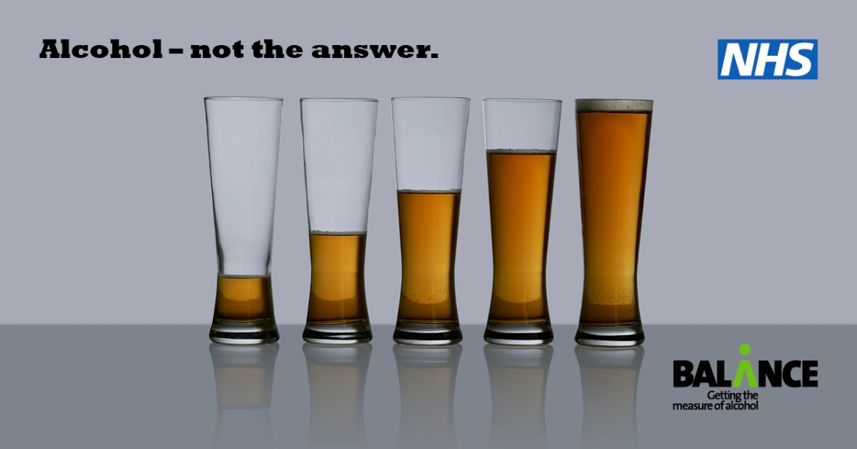

Alcohol – Not the Answer
Campaign toolkit – November 2020

1/ Introduction
2/ Insight and target audience
3/ Channels and timings
4/ Script (TV and radio)
5/ Calls to action
6/ Key messages
7/ Supporting the campaign
8/ Template article/ web copy
9/ Social media posts

1/ Introduction

This toolkit is designed to help partners support a major new alcohol health campaign launching across the North East and North Cumbria from November 11 from Balance.

Alcohol - Not the Answer is a response to concerns about rising levels of alcohol consumption, aimed at the estimated half a million people in our region drinking above the Chief Medical Officer’s low risk guidelines, and who research shows are likely to be drinking even more as a result of pressure and anxiety during COVID (see section 2: Insight and Target Audience).

Throughout 2020, Balance has been engaging the public around the issues with alcohol and COVID through our Stay Healthy Stay Safe initiative. This followed a warning by the World Health Organisation around the risks of alcohol during Covid, including that alcohol use weakens the immune system and can reduce the ability to cope with infectious diseases such as Covid.

The “Alcohol- Not the Answer” campaign will now build upon these themes and underline the broad range of physical and mental health problems alcohol causes, why especially it is important to reduce our drinking, and highlights practical advice to help people cut down.

The campaign is being funded by the support of the NHS North East and North Cumbria Integrated Care System, our 7 LA funders and with additional support from Tees Valley local authorities.

From launch, through Alcohol Awareness Week and into December, “Alcohol - Not the Answer” will follow four main themes from immune system and mental health through to cancer and heart disease.

We are encouraging all partners to support the campaign but appreciate this comes at an incredibly busy time. We have created a full suite of ready to use resources to ensure it is quick and easy for partners can show their support when time and availability is restricted.

2/ Insight and target audience

We know the UK has a problem with alcohol - but research is showing the COVID-19 pandemic has compounded this. It was recently estimated that 8.4 million people nationally are now drinking at higher risk levels, nearly twice as many as in February . Newspapers and social media have been filled with stories about people stockpiling alcohol or normalising “wine o clock”, while the mental health charity Mind has spoken of a mental health emergency. It is clear alcohol is being used as a coping mechanism, with potentially disastrous results for our health.

Our target audience is men and women of all ages who are drinking more during COVID, with a focus on C2DE socioeconomic groups.

A number of reports during 2020 highlight there is a cause for concern:

April: Shortly after lockdown, research by Balance and Alcohol Change found that more than 26% of North East adults who drink alcohol were drinking more often since lockdown began. Worryingly, it was those already drinking the most who were likely to be drinking even more.

Sept: Royal College of Psychiatrists analysis of latest Public Health England data on the indirect effects of Covid-19 found that over 8.4 million people nationally were now drinking at higher risk, up from 4.8 million in February.

Oct: an online survey carried out prior to the campaign by Balance found that over 18% of people in the North East were drinking more – an est. 397,000 people. 8/10 of these were drinking at increasing and higher risk levels.

Research prior to COVID suggests around 1 in 4 people in the North East are drinking more than the Chief Medical Officer’s guidelines of no more than 14 units a week.

3/ Channels and timings

“Alcohol - Not the Answer” launches on Wednesday, November 11 and runs for four weeks until December 8.

Channels will include:
- TV advertising on ITV Tyne Tees and ITV Borders
- Video on Demand advertising on ITV Hub – ITV Tyne Tees and ITV Borders
- Radio advertising on Metro FM, TFM and Smooth in the North East and CFM in North Cumbria.
- Advertising on Facebook and Instagram in the North East and North Cumbria
- Digital display advertising in the North East and North Cumbria

We are taking a week-by-week approach to PR and social media set out broadly into four strands with video content and interviews with clinicians:

Week 1 (11 Nov) – alcohol and the immune system during Covid
Week 2 (w/c 16 Nov) – mental health (this year’s theme for Alcohol Awareness Week – see https://alcoholchange.org.uk/get-involved/campaigns/alcohol-awareness-week-1/about-alcohol-awareness-week)
Week 3 (w/c 23 November) – alcohol and cancer
Week 4 (w/c 30 Nov) – alcohol and cardiovascular disease/ stroke/ hypertension

4/ Script (TV and radio)

The TV advert will see liquid being poured into a glass to different levels, with the harms appearing as words on screen

These are worrying times, but alcohol isn’t the answer. You don’t have to be a heavy drinker for it to affect your health.

Alcohol can weaken the immune system, leaving you more vulnerable to the effects
of infectious diseases like Covid.

And while you might think it helps you relax, it’s a depressant, which can increase
anxiety and lower your mood.

It can also increase your risk of cancer, heart disease and stroke.

Reduce your drinking. Your body and mind will thank you.

Find out how at reducemyrisk.tv

Watch the TV advert at https://youtu.be/SZJUeJXU-PU

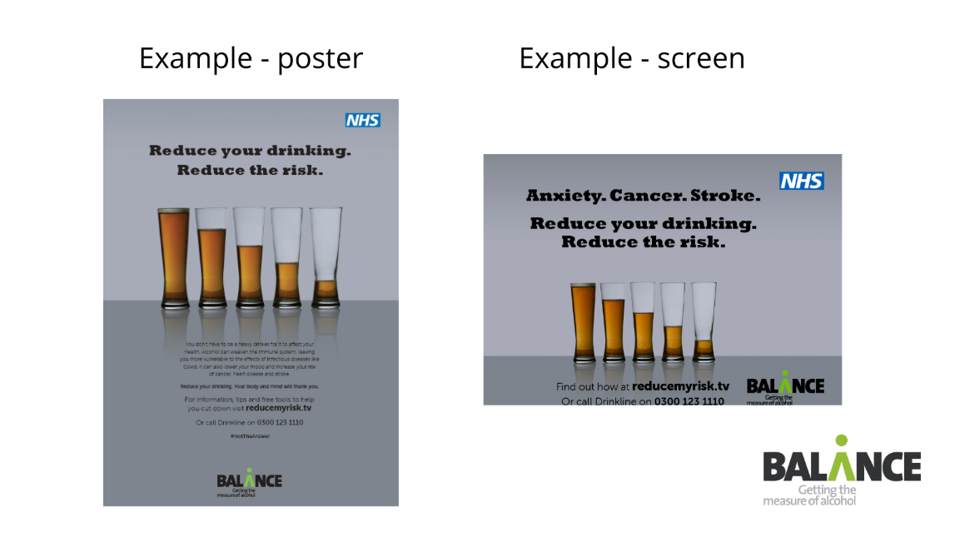

5/ Calls to action

The main call to action is for people to reduce their drinking, and all campaign activity will encourage people to visit the Balance reducemyrisk.tv website.

Reduce my Risk has now had over 460,000 visit since launch and offers a wide range of content about alcohol, including hints, tips, real stories and blogs, units explained and facts about alcohol’s health risks. In particular we will be promoting:

- A new campaign landing page detailing the harms of alcohol from cancer and CVD to weakening the immune system, mental health and weight gain.
- An updated quiz challenging people to test their knowledge about alcohol units
- Downloads of the PHE Drink Free Days app

6/ Key messages

Many people have found themselves drinking more during the pandemic – and at levels that can harm health.

It is more important than ever before to look after our mental wellbeing and physical health – and cutting back on alcohol can help us do that.

Alcohol can be more harmful than you realise and just a couple of glasses a night can put you at greater risk.

Drinking no more than 14 units a week helps keep risks from alcohol low.

Immune system:
- Alcohol use, especially heavy use, can weaken the immune system and can reduce the ability to cope with infectious diseases such as coronavirus
- Alcohol will not stimulate immunity and virus resistance – it will not destroy the virus

From the World Health Organisation

Cancer: alcohol raises the risks of at least seven types of cancer – of the breast, bowel, mouth, larynx, oesophagus, upper throat and liver. See more at http://www.reducemyrisk.tv/types-of-cancer/

Heart: Drinking can have a harmful effect on your heart. Alcohol can cause abnormal heart rhythms and damage to the heart muscle. See more information about alcohol and cardiovascular disease from the British Heart Foundation.

Stroke: alcohol can increase the risk of stroke, even if you don’t drink very large amounts. If you’ve had a stroke, alcohol could increase your risk of another stroke. This is because alcohol contributes to a number of medical conditions that are risk factors for stroke, such as high blood pressure, diabetes, being overweight, an irregular heartbeat and liver damage. See more information about alcohol and stroke from the Stroke Association

Blood pressure: Regularly drinking too much alcohol can raise your blood pressure to unhealthy levels which can lead to other serious health conditions. High blood pressure is the most important risk factor for stroke. More than 1 in 4 adults nationally are living with high blood pressure. See more information about alcohol and hypertension from the Stroke Association

Mental health
Alcohol is sometimes used by people to try and help manage symptoms of anxiety and depression, but excessive drinking is likely to make those symptoms worse. Managing your drinking and getting the right support are crucial to good mental health. See Alcohol Change.
About 1 in 4 people in the UK will experience a mental health problem each year.
And also:

Liver: Drinking too much alcohol over a long period of time means the liver doesn’t get a chance to recover. This can result in serious and permanent damage. Alcohol is the leading cause of liver disease in the UK, which is the biggest killer of 35 to 49-year olds.

Weight
Many people aren’t sure about the number of calories in their drinks but reducing your drinking is an important way to help you lose weight.

Being overweight can lead to many serious health conditions and can increase your risk of heart and circulatory diseases such as heart attack, stroke and type 2 diabetes. Visit http://www.reducemyrisk.tv/hint/how-many-calories-are-in-alcohol/

Social distancing: Alcohol can blur the lines when it comes to social distancing. It is more important than ever to keep track of our drinking to protect ourselves and others.

Cutting back:
If you reduce your drinking, your body and mind will thank you.

Reducing your drinking can reduce your risks, do wonders for your waist-line and bank balance and generally make you feel lots better in yourself.

Staying within 14 units a week is the best thing we can all do to keep our risks from alcohol low to stay healthy right now. Fourteen units a week means around six pints of regular strength beer or lager, six standard glasses of wine or seven double 25ml measures of spirits.

Taking more drink free days is a good way to cut down. Having days where you don’t drink can help your body recover and break the cycle of daily drinking. The Drink Free Days app can help.

7/ Supporting the campaign

We appreciate local partners are incredibly busy at present, so we have tried to make supporting the campaign even easier than usual. Assets include those in this toolkit and a separate file of images, screens and animations:

- Posters we have artwork suitable both for larger scale professional print runs or without print marks for hospital wings, GP surgeries or council buildings (subject to Covid policies)
- Digital screens for public waiting areas – waiting rooms, reception areas, housing offices etc.
- Template article / web copy for websites and in-house publications (see below)
- 15 sec videos for social media
- Social media posts and images for Facebook and Twitter feeds using the campaign hashtag #NottheAnswer. We’ve also included Stay Healthy Stay Safe graphics and 14 units images and videos (Jpegs in the separate digital toolkit)

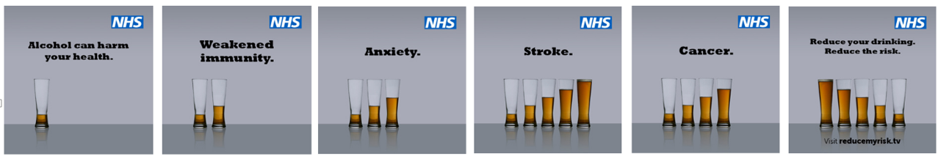

8/ Template article/ web copy

It is more important than ever before to be looking after ourselves. But drinking too much alcohol can put our health at risk and make us feel worse during the pandemic.
COVID-19 has been a worrying time, but drinking most days can weaken our immune system against infectious diseases like Covid. It can also increase the risk of cancer, heart attack, anxiety and stroke.
Balance is launching a new campaign “Alcohol - Not the Answer” to encourage people to cut down and take more drink free days. Figures suggest that nearly 400,000 people in the North East and over 8m people nationally have been drinking more since the pandemic began, many at worryingly high levels.
Here’s how alcohol can affect us:
Immune system: Alcohol use, especially heavy use, can weaken the immune system and leave us more vulnerable to infectious diseases like Covid.
Health: Regularly drinking above 14 units a week increases the risk of heart disease, stroke and seven types of cancer. Cutting down is one great way to help reduce blood pressure.
Mental health: according to the Royal College of Psychiatrists, regularly drinking alcohol affects the chemistry of the brain and can increase the risk of depression, low mood and anxiety. Drinking could be making you feel more tired and more down.
Weight: Many people aren’t sure about the number of calories in their drinks - reducing how much alcohol we drink is a good way to cut our calories.
Colin Shevills, Director of Balance, said: “These are worrying times, but drinking more is not the answer. In fact it might be making many people feel worse.
“We are encouraging people to take more drink free days and try to stay within no more than 14 units a week. Keeping alcohol in check is an important way to protect our overall health and fitness for the time when we emerge from this crisis.”
Chief Medical Officer guidelines are that men and women should not drink more than 14 units a week to keep health risks from alcohol low. 14 units means around six pints of regular strength beer or lager, six standard glasses of wine or seven double measures of spirits a week.
For tips, tools, stories and advice to help you cut down visit reducemyrisk.tv
Tips.

- Try not to stockpile alcohol. Limit the amount of alcohol you buy in and opt for non-alcoholic drinks to help you stay within the 14 unit low-risk weekly guidelines.
- Having at least three drink-free days every week can help you cut down on how much you’re drinking. Visit http://www.reducemyrisk.tv/support/ to download the free Drink Free Days app from Public Health England.
- Think about being a good role model to your kids around alcohol, which includes how often and how much you drink alcohol. None of us want to teach our children that it’s normal to drink every night or to start each day at 4pm.
- You can track your units, calories and money saved when you cut down or cut out alcohol through the Try Dry app from Alcohol Change.
- Use a measure to pour your drinks – home-poured measures are often a lot more generous than those you’d get in the pub and contain more units and calories than a standard measure.
- If you feel like you should cut down, you’re in good company. An estimated 1 in 3 North East drinkers cut down or stopped drinking alcohol during the spring / summer lockdown.
- If you’re feeling stressed or anxious, it can be tempting to turn to alcohol to help you relax. But here are some top ways to unwind from Alcohol Change UK that don’t involve alcohol https://alcoholchange.org.uk/blog/2018/five-ways-to-relax-without-alcohol
- When it comes to alcohol and young people, parents often find it confusing to know what to do for the best. The safest option is to follow the Chief Medical Officer guidelines that it is safest and healthiest for children to not drink before the age of 18. For advice every parent needs to know visit whatstheharm.co.uk
- Finally, if you are concerned about your own drinking or someone else’s, call the national alcohol helpline Drinkline on 0300 123 1110 (weekdays 9am–8pm, weekends 11am–4pm).
- Consuming alcohol is not an excuse to drop social distancing. Keeping to social distancing rules can help prevent pressure on the NHS.

9/ Social media posts

There are three types of images below – the Not the Answer campaign, Stay Healthy Stay Safe, and 14 units. Jpegs are contained in the digital links sent with the covering campaign email and below https://wetransfer.com/downloads/9289fa4d258b7a04378dbdc05a376f2020201109130834/da03035ded37e0a3ddc01303787241e020201109130918/ea3859

Please follow and share / retweet our posts from @BalanceNE

Not the Answer

LAUNCH WEEK 1 – alcohol and health risks during Covid / general | Image/ video
Key Balance social media content – video by Dr James Crosbie, GP, consultant gastroenterologist and North East and North Cumbria ICS lead for alcohol
  These are worrying times, but alcohol is #NotTheAnswer. It can make us feel worse and put our health at risk. We are supporting the new campaign from Balance to highlight the risks to physical and mental health and the benefits of cutting down. Visit http://www.reducemyrisk.tv | 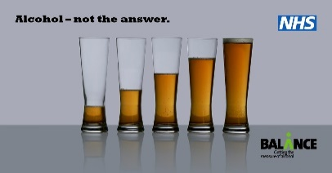
We all need to stay fit and healthy right now – but alcohol can harm our immune system and reduce our ability to fight off infectious diseases. It can also increase the risk of cancer, heart attack, anxiety and stroke. For tips, free tools and advice to cut down visit http://www.reducemyrisk.tv | 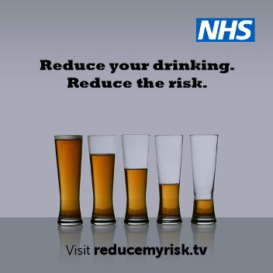
2020 has affected us all in different ways but drinking too much is never a good way to cope with the pressures of Covid. For tips, free tools and advice to cut down visit http://www.reducemyrisk.tv
It’s more important than ever to look after our physical and mental health, and Chief Medical Officer guidance is for men and women to drink no more than 14 units of alcohol a week to keep our risks low. That’s no more than 6 standard glasses of wine, six pints or beer or lager or seven double spirits a week.  Do you know your units? Try this quiz at http://quiz.reducemyrisk.tv/  Feel like alcohol is getting out of hand? Here are two good ways to cut down on alcohol:  - Don’t stockpile  - Take more Drink Free Days. Limit the amount of alcohol you buy in and opt for non-alcoholic drinks to help you stay within the 14 unit low-risk weekly guidelines. For tips, free tools and advice to cut down visit http://www.reducemyrisk.tv | 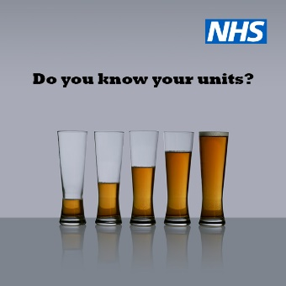  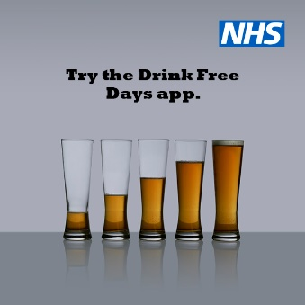
  We all need to stay healthy right now – but alcohol can harm our immune system and our ability to fight off infectious diseases. It can also increase the risk of cancer, heart attack, anxiety and stroke. Visit http://www.reducemyrisk.tv #NottheAnswer  These are worrying times, but alcohol is #NotTheAnswer. It can make us feel worse and put our health at risk. We are supporting the new campaign from @BalanceNE to highlight the risks to physical and mental health and benefits of cutting down. Visit http://www.reducemyrisk.tv  How much is too much when it comes to #alcohol? Do you know your units? Try the quiz from @BalanceNE at www.reducemyrisk.tv | 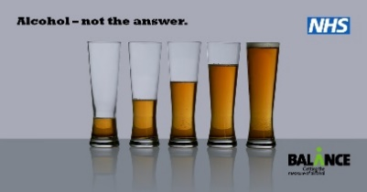
Week 2 – Alcohol Awareness Week
Key Balance social media content – video and blog by Dr Eilish Gilvarry, consultant psychiatrist with Northumberland, Tyne & Wear NHS Foundation Trust
*NB W/c 16th November is also Alcohol Awareness Week, which is similarly focusing on mental health this year. There are lots of resources you can download from https://alcoholchange.org.uk/get-involved/campaigns/alcohol-awareness-week-1/about-alcohol-awareness-week/take-part-in-alcohol-awareness-week/alcohol-awareness-week-2020-resources  Relying on a drink to unwind? It might be tempting after a hard day or when you’re stressed, but alcohol can actually have the opposite effect, leaving you feeling more tired, more down and more anxious. Reducing your drinking can make you feel more positive and improve your sleep.  For tips, advice, real stories and free apps to help you cut down, visit http://www.reducemyrisk.tv/ | 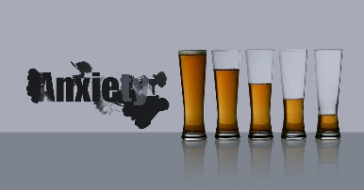
It’s #AlcoholAwarenessWeek and this year, the focus is on alcohol and mental health. Around 1 in 4 people in the UK experience a mental health problem each year  Whilst alcohol might be a coping mechanism, the feelings associated with drinking are often short lived. In the long-term, drinking too much, too often can result in low mood and anxiety. Read more at https://alcoholchange.org.uk/alcohol-facts/fact-sheets/alcohol-and-mental-health | 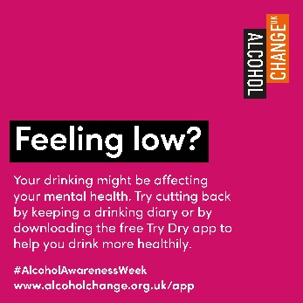
We are supporting #AlcoholAwarenessWeek- alcohol can leave you more tired, down and anxious. Reducing your drinking can make you feel more positive and improve your sleep. For tips, advice, real stories and free apps to help you cut down, visit http://www.reducemyrisk.tv/  2020 has taken its toll on the nation’s mental health, but turning to alcohol in times of uncertainty is #NotTheAnswer. Find out more about alcohol’s impact on mental health: http://www.reducemyrisk.tv/hint/how-does-alcohol-affect-your-mental-health/  #AlcoholAwarenessWeek | 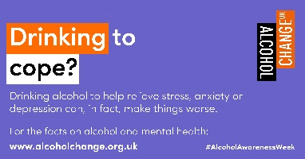
Week 3 – alcohol and cancer
We might not want to think about it, but there are proven links between alcohol and 7 types of cancer – including breast, bowel, mouth and throat. Cutting down how much you drink can help lower your risk of cancer. Find out more at www.reducemyrisk.tv  Breast cancer is the most common cancer in the UK. Whilst there are things we can’t change to reduce the risk, like age, cutting back on alcohol is one thing we can do. Find out more: http://www.reducemyrisk.tv/hint/a-doctors-view-on-alcohol-and-breast-cancer/  The more you drink, the greater your risk of #7cancers. Reducing consumption and taking more drink free days are two ways people can cut down and reduce the risk. For tips, advice, real stories and free apps to help you cut down, visit http://www.reducemyrisk.tv/  The risk of developing cancer is different for everyone – but reducing the amount we drink is one way we can reduce our risk. Visit http://www.reducemyrisk.tv/ for hints & tips to cut down #NotTheAnswer | 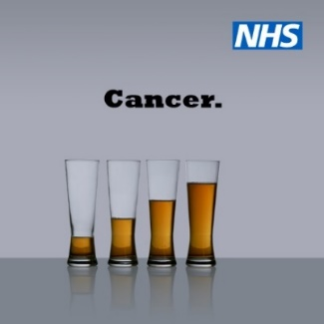  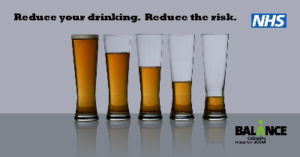
Week 4 – Alcohol and CVD

It’s estimated that around 1 in 4 people have high blood pressure. Cutting back the amount you drink and how often you drink can help to lower your blood pressure and reduce your risk of developing heart disease and stroke. For tips, advice, real stories and free apps to help you cut down, visit http://www.reducemyrisk.tv/  If you’re trying to reduce your blood pressure, reducing the amount you drink is a great place to start. Our three top tips are:  - Stick within the 14 unit guidelines as specified by the Chief Medical Officer  - Build in at least 3 alcohol-free days a week  - Know your triggers and have distractions to hand to help keep you on track  For more hints and tips, visit http://www.reducemyrisk.tv/hint/top-tips-to-help-you-cut-down-alcohol/  When it comes to looking after our bodies, alcohol is #NotTheAnswer. If you’re looking to reduce your blood pressure, cutting back on drinking is a great place to start. For more tips, visit http://www.reducemyrisk.tv/hint/top-tips-to-help-you-cut-down-alcohol/ | 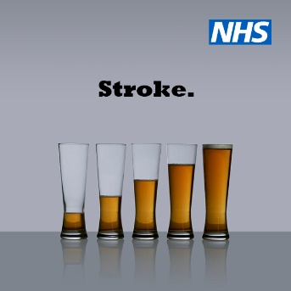

Stay Healthy Stay Safe graphics

Stay Healthy Stay Safe was a PR campaign running during 2020 in response to Covid.

We all need to stay fit and healthy right now – but alcohol can harm our immune system and reduce our ability to fight off infectious diseases. Visit http://www.reducemyrisk.tv/ | 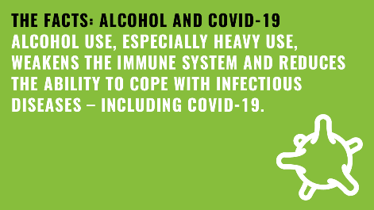
Social distancing and alcohol don’t mix. Alcohol can be harmful at the best of times, but these aren’t the best of times – so that’s why it’s even more important to keep track of our drinking to protect ourselves and others. | 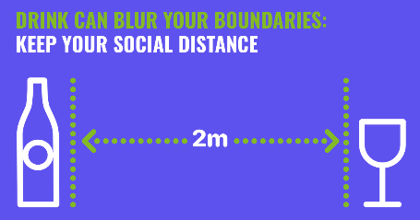
With tighter restrictions, we’re urging people to stay safe & remember social distancing guidelines. Alcohol affects our judgement & can affect our ability to fight infections. http://www.reducemyrisk.tv/
This is an important time to be looking after ourselves. Alcohol is never a good way to cope with worry – and can leave us feeling worse. Read advice, tips and tools to cut down at http://www.reducemyrisk.tv/ | 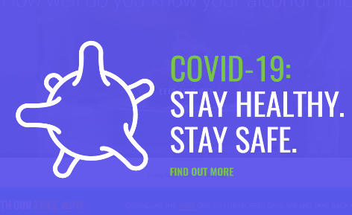
The COVID-19 pandemic is a stressful time. But can alcohol make us feel more down? Consultant psychiatrist Prof Eilish Gilvarry gives some thoughts – read her blog at http://www.reducemyrisk.tv/hint/how-does-alcohol-affect-your-mental-health/ | 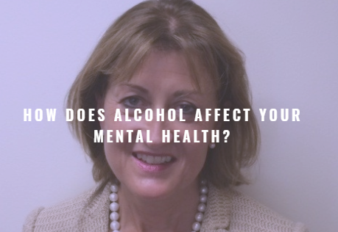
A good way to cut down on alcohol is not to stockpile. Limit the amount of alcohol you buy in and opt for non-alcoholic drinks to help you stay within the 14 unit low-risk weekly guidelines. To find out more visit http://www.reducemyrisk.tv/hint/covid-19-stay-healthy-stay-safe/ | 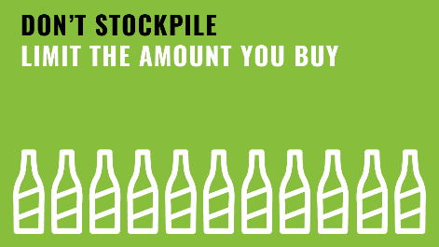
How many slices of pizza in a pint? And how long would I have to run to burn off two glasses of wine? If you’re watching your weight, cutting down on alcohol is a good step. Watch our video and find out more at http://www.reducemyrisk.tv/hint/how-many-calories-are-in-alcohol/ | 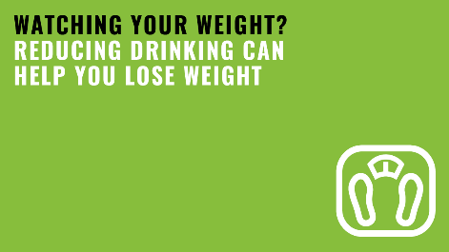
You might think alcohol helps you to deal with stress and anxiety but it’s not a good way to cope. Alcohol is known to increase feelings of anxiety, depression, stress and other mental health conditions. Visit https://alcoholchange.org.uk/blog/2020/coronavirus-top-tips-on-alcohol-and-mental-health | 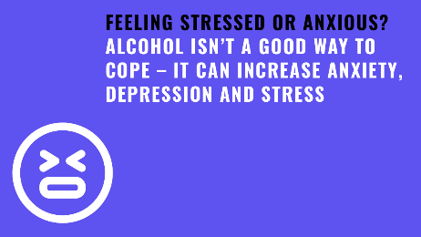
Feel like you’re drinking too much? Having at least three drink-free days every week is a great way to cut down on how much you’re drinking. Visit www.reducemyrisk.tv to download the free Drink Free Days app. | 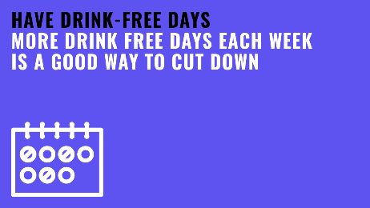
The @CMO_England guidelines recommend people should drink no more than 14 units a week to keep drinking to a ‘low risk’ level – but how much is this? Find out at www.reducemyrisk.tv/units-explained/ | 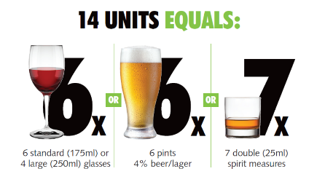
An estimated 1 in 3 North East drinkers cut down or stopped drinking alcohol during lockdown. But if you’re worried about you or someone else drinking too much, help is out there. | 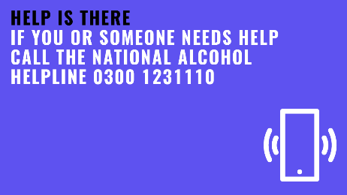
You won’t see it on the label, but reducing your drinking can help you lose weight. A glass of wine or a pint can contain over 220 calories – nearly as many as a McDonalds’ hamburger. | 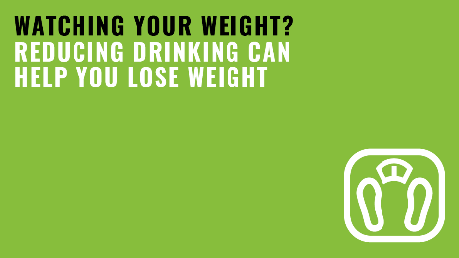
If you’re feeling stressed or anxious, it can be tempting to turn to alcohol to help you relax. But here are some top ways to unwind from @AlcoholChangeUK that are less risky: https://alcoholchange.org.uk/blog/2018/five-ways-to-relax-without-alcohol | 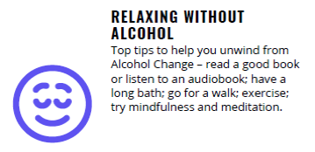
When it comes to alcohol and young people, the safest option is to not let them drink before the age of 18, so make sure they don’t have access to alcohol and if you drink, try not to drink around them. Visit www.whatstheharm.co.uk. | 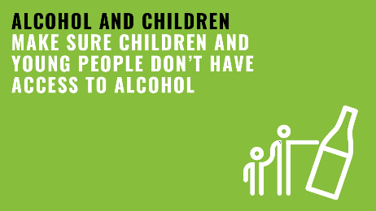

14 units – social posts and graphics
We all want to stay in good physical and mental health right now - a good way is not drinking too much and staying within Chief Medical Officer limits of no more than 14 units a week. For tips visit www.reducemyrisk.tv | 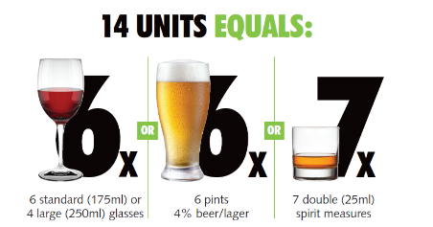
How much is too much when it comes to #alcohol? Do you know your units? Try this quiz from @BalanceNE at www.reducemyrisk.tv | 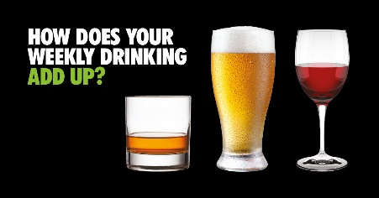
It’s more important than ever to look after our physical and mental health. The Chief Medical Officer advises men and women don’t drink more than 14 units of alcohol a week to keep our risks from alcohol low. That’s no more than 6 standard glasses of wine, six pints or beer or lager or six double spirits a week  How does your drinking add up? Try this quiz at www.reducemyrisk.tv | 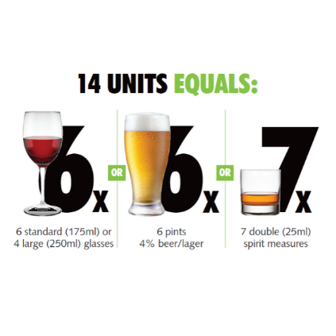
If you drink alcohol, do you know your units? Why not have a go at this quiz from Balance to see how you compare with the weekly low risk limit? Try it out at www.reducemyrisk.tv | 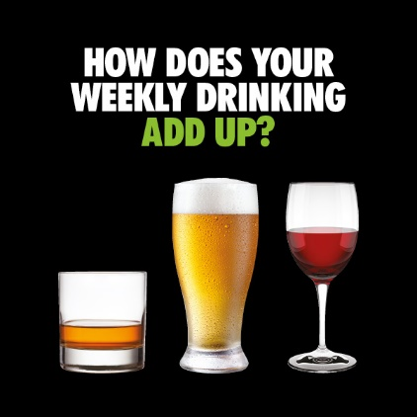

https://www.euro.who.int/__data/assets/pdf_file/0007/442690/FAQ-COVID-19-alcohol.pdf:
https://www.rcpsych.ac.uk/news-and-features/latest-news/detail/2020/09/14/addiction-services-not-equipped-to-treat-the-8-million-people-drinking-at-high-risk-during-pandemic-warns-royal-college
https://www.mind.org.uk/media-a/5929/the-mental-health-emergency_a4_final.pdf?
https://www.euro.who.int/__data/assets/pdf_file/0007/442690/FAQ-COVID-19-alcohol.pdf
https://www.euro.who.int/__data/assets/pdf_file/0010/437608/Alcohol-and-COVID-19-what-you-need-to-know.pdf
https://alcoholchange.org.uk/alcohol-facts/fact-sheets/alcohol-and-mental-health
https://britishlivertrust.org.uk/liver-disease-is-now-the-biggest-cause-of-death-in-those-aged-between-35-49-years-old-new-report-reveals/

