8 Sleeping Positions and Their Effects on your Health.

Getting enough sleep is most important – but did you know that how you sleep can also impact your health?

Let’s take a look at eight common sleeping positions and what they do to your body.
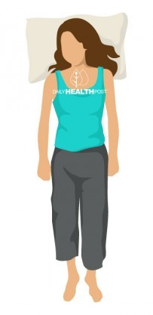
- On your Back, Arms at sides

Best position to sleep
Sleeping on your back with your arms at your side is generally considered to be the best sleeping position for spine health and it’s good for your neck, too, as long as you don’t use too many pillows. That said, back sleepers tend to snore more than those in any other position and sleep apnea is strongly associated with sleeping on the back.
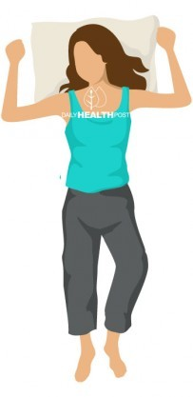

- On your Back, Arms up
This so-called “starfish” position is also good for the back. Whether you have your arms up around your pillow or not, sleeping on your back may also help to prevent facial wrinkles and skin breakouts. However, like the arms-down back sleeping position, this one can also result in snoring and problems with acid reflux. Plus, having your arms up can put pressure on nerves in your shoulders, leading to pain.

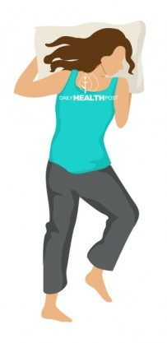
- Face Down

Sleeping on your stomach can improve digestion but unless you’ve developed a way to breathe through your pillow, it most likely leads to you tilting your face in one direction or the other. This can put a lot of strain on the neck. Sleeping face down can also cause back pain, as the curve of the spine is not supported.

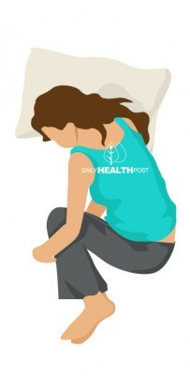
- Foetal Position

Sleeping all curled up into a ball with your knees drawn up and your chin tilted down might be comfortable but it’s probably one of the worst sleeping positions to consider as it can do a number on your back and neck.
The extreme curl of the foetal position can also restrict deep breathing. That considered, sleeping like a fetus can have you sleeping like a baby if you typically have problems with snoring or if you’re pregnant.

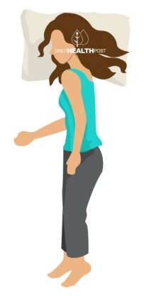
- On Side, Arms at Sides

When you’re sleeping on your side with both arms down, the spine is best supported in its natural curve. This can help reduce back and neck pain while also reducing sleep apnea. The downside? Sleeping on the side can contribute to skin aging due to gravity, meaning facial wrinkles and sagging breasts.

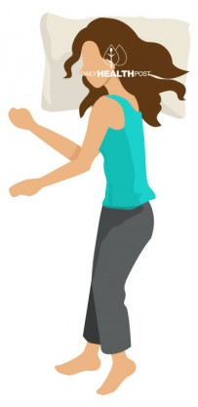
- On Side, Arms Out

This position has many of the same benefits of sleeping on your side with your arms straight down. However, any side sleeping can cause shoulder and arm pain due to restricted blood flow and pressure on the nerves, which may be exacerbated by having your arms out in front of you.

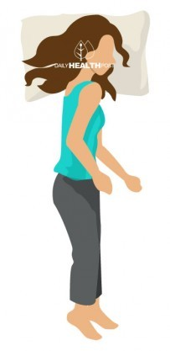
- On the Right Side

If you’re a side-sleeper, which side you sleep on also makes a difference. Sleeping on the right side can worsen heartburn while sleeping on the left side can put strain on internal organs like the liver, lungs, and stomach (while minimizing acid reflux). For pregnant sleepers, doctors typically advise sleeping on the left side, since this can improve circulation to the fetus.

- Pillow-Supplemented
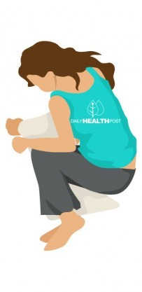
Choosing a proper sleeping position is important but regardless of which sleeping position you prefer, it’s highly likely that you can get a better night’s rest with less pain in the morning by supplementing your body with a pillow.
Back sleepers can put a small pillow under the arch of their spine, side sleepers can place a pillow between their knees, and stomach sleepers can place a pillow under their hips to support the joints and allow for full, pain-free relaxation.

