12 Sneaky Foods That Make You Sleepy
and 11 that will keep you up

Foods That Make You Sleepy
Stick to these late-night bites, and peaceful slumber will be yours.
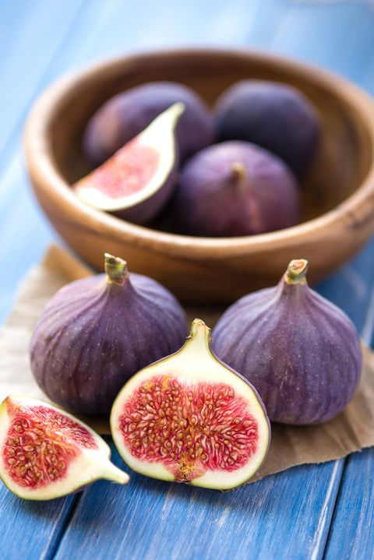
- Figs
"Figs pack potassium, magnesium, calcium, and iron," says Jaclyn London, MS, RD, CDN, Nutrition Director at the Good Housekeeping Institute. "These minerals help with blood flow and muscle contraction, which are key for falling asleep." Besides crushing your dessert craving, each fig also packs some additional fibre that'll keep you full.

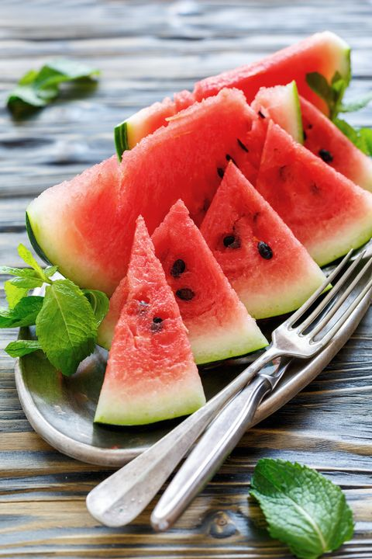
- Watermelon

It's all in the name. Each 2-cup serving is half (you guessed it) water, which will hydrate you before bed and eliminate post-dinner hunger pains due to the fibre and volume.

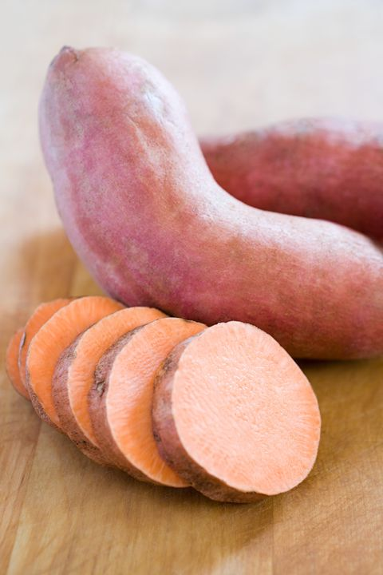
- Sweet Potato Toast
Swap baked sweet potatoes for traditional night-time toast. Sweet potatoes are great sources of potassium, magnesium, and calcium to help you relax. Top with a drizzle of honey and pinch of sea salt, or a tablespoon of nut butter for a post-dinner treat.

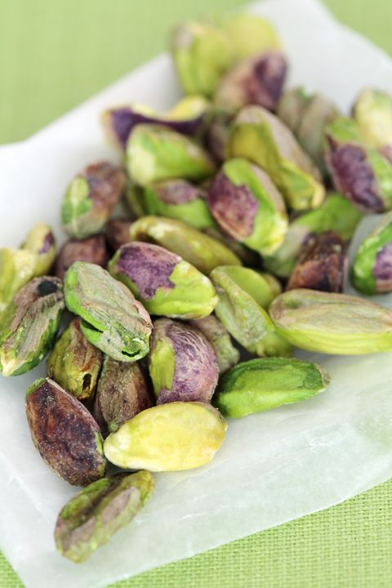
- Pistachios
Pistachios hit the sleep-inducing jackpot, packing in protein, vitamin B6, and magnesium, all of which contribute to better sleep. Refrain from a shell-cracking frenzy, though. Don't exceed a 1-ounce portion of nuts - anything too high in calories can have the reverse effect of keeping you awake!
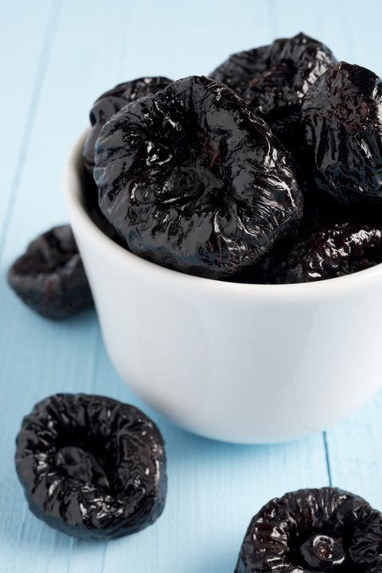
5.Prunes
The nutrients in dried plums — vitamin B6, calcium, and magnesium, to name a few — help make melatonin, the hormone that regulates sleep. Use prunes as a whole-grain toast topping, mix them into trail mix, or eat them on their own about 30 minutes before bedtime.
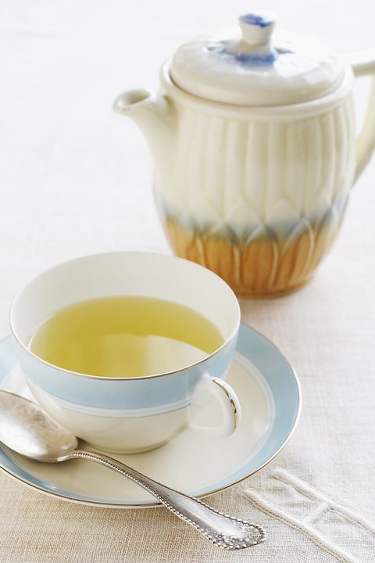
6.Herbal Teas
No surprise here, but herbal tea has tons of snooze-promoting properties. Camomile tea is excellent for calming nerves before bedtime. It's also hydrating and stomach-soothing, same as ginger tea.

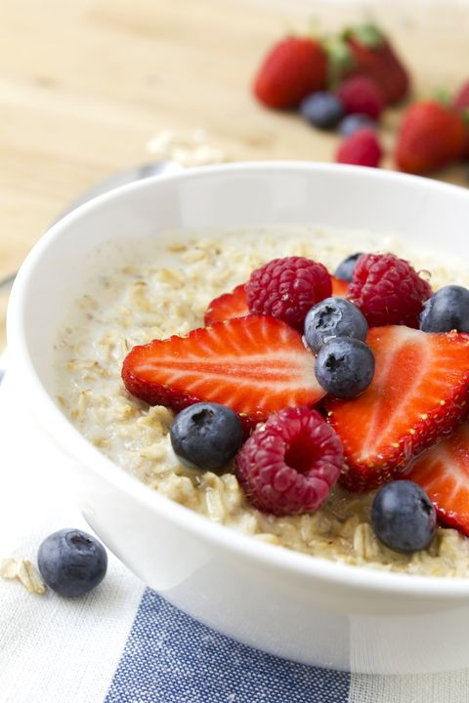
7. Oats
It may be a favourite for breakfast, but you might want to pair a bowl of porridge oats with some coffee to make it through the day. Grains in oatmeal trigger insulin production much like whole-grain bread. They raise your blood sugar naturally and make you feel sleepy. Oats are also rich in melatonin, which relaxes the body and helps you fall asleep."
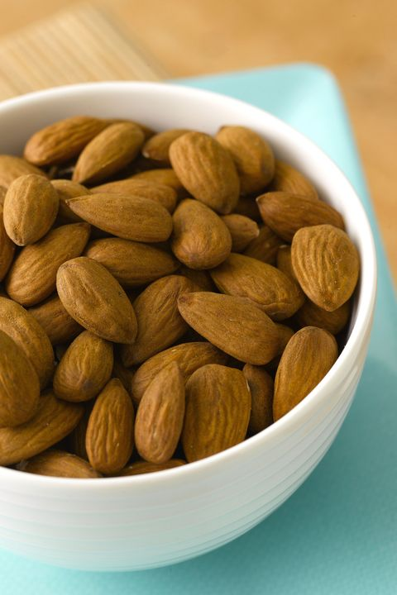
8. Almonds
Just a handful of these and you'll be dozing off in no time. Almonds contain tryptophan and magnesium, which both help to naturally reduce muscle and nerve function while also steadying your heart rhythm.

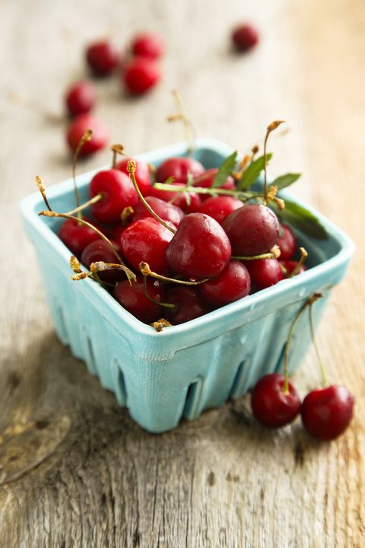
9. Cherries
The best way to get a good night's sleep is to increase your melatonin intake. Cherries, along with nuts and oats, are a natural source of melatonin. When eaten regularly, they can help regulate your sleep cycle.

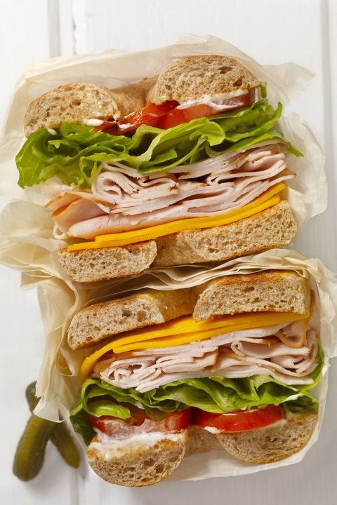
10. Turkey
The battle of the turkey is still being fought today. Some experts say it has no effect on sleep, and the annual Christmas Day food coma is caused by the amount of food you eat, not the bird itself. But turkey does have tryptophan in it, which gets metabolized into serotonin and melatonin, two of the main chemicals responsible for your dozing off.

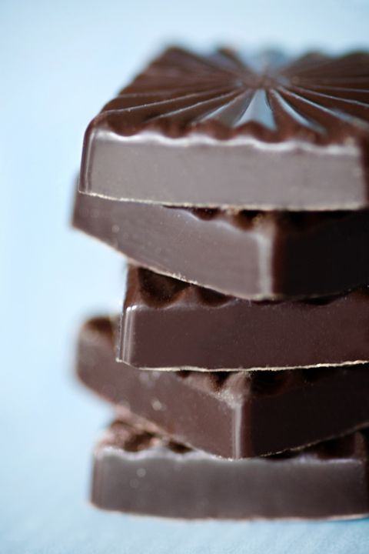
11. Dark Chocolate

Don't worry — you can eat chocolate day and night (whew!). Dark chocolate contains serotonin, which relaxes your body and mind. Not to mention the other health benefits dark chocolate has too.

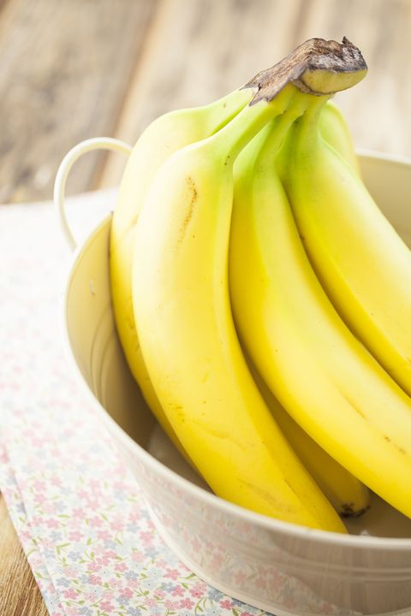
12. Bananas
The magnesium and potassium in bananas serve as muscle and nerve relaxants. Vitamin B6 found in the fruit also converts tryptophan into serotonin, increasing relaxation even more.

Foods That Keep You Awake

Check the clock before indulging in these favourite treats, or risk tossing and turning all night long.
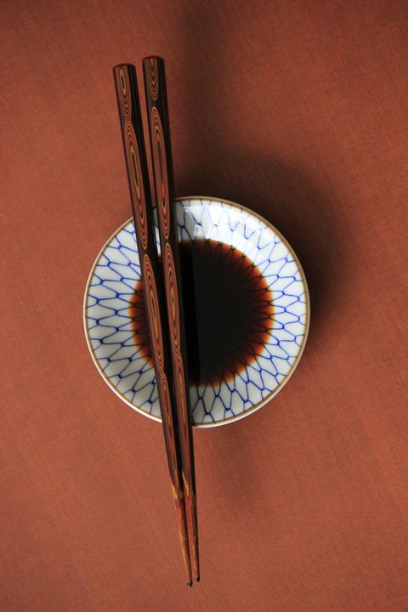
1.Soy Sauce
Hold back on dunking your sushi unless you want to wake up in the middle of the night parched. Just one teaspoon of soy sauce contains more than half of your daily recommended allowance for salt. Choose low-sodium versions and push forward dinnertime to at two hours before bed.

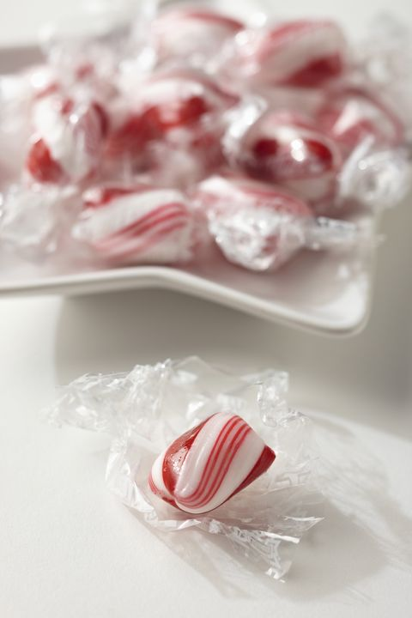
2. Peppermints
Minty-fresh sweets and chewing gum act as stimulants, not relaxers, so put those sticks away until tomorrow.

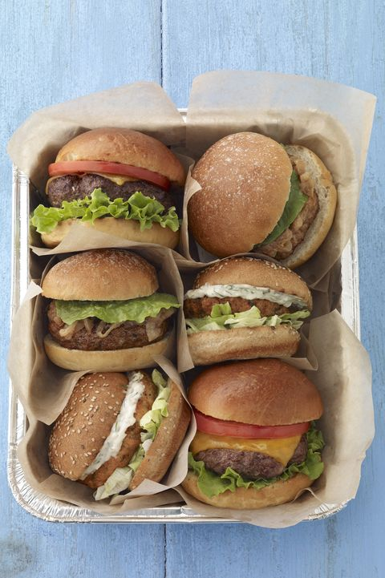
3. Burgers
Don't swing by the drive-thru if you want to hit the hay early. High-fat foods like burgers and pizza take longer to digest, messing with your sleep.

4.Orange Juice
Squeezed citrus, like orange and grapefruit juices, might trigger a nasty case of heartburn. The acidic foods can cause reflux in some people, so steer clear if you want to rest easy.

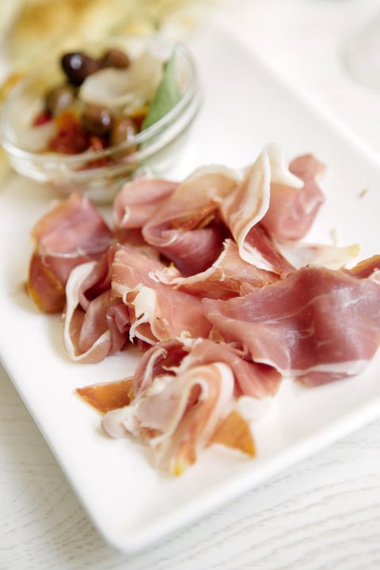
- Processed or Smoked Meats
Leave this one on the deli counter. Processed meats contain high levels of sodium, which will have waking you up and reaching for a glass of water. These meats also aren't the healthiest ones to munch on either, sleep patterns aside.

- Spicy Foods
Those hot wings may taste damn good during the football game, but they aren't going to feel so great come bedtime — especially if you're prone to heartburn. Eat your favourite hot foods early enough in the day to prevent a sleepless night later.

- Coffee
You've known this guy for years. He's gotten you through countless all-nighters and pepped you up for that 8 a.m. Monday morning presentation. But did you know that caffeine isn't actually giving your body any energy? Though caffeine does provide us with that feeling of alertness, it's just a stimulant.

- Alcohol
Even though it's a depressant, alcohol will, oddly enough, keep you up at night. Many people use alcohol to help them relax, but it actually prevents your body from entering the deep stages of sleep.

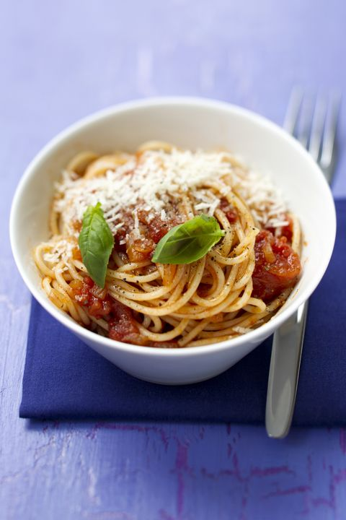
- Tomato-Based Sauces
Have that plate of pasta at least few hours before tucking in at night. Tomato-based foods have a tendency to cause acid reflux and heartburn, which will prevent you from having a good night's sleep.

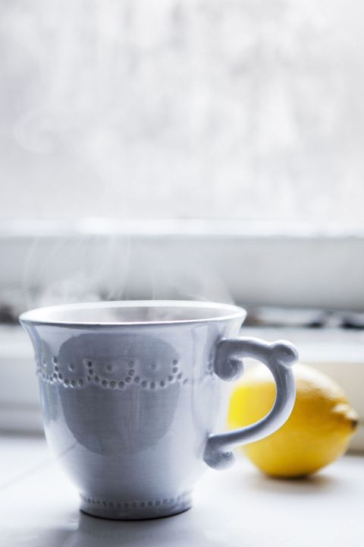
10.Black Tea
Herbal teas are great for sleeping, but avoid black varieties. It's another source of caffeine, which can keep you from drifting off.

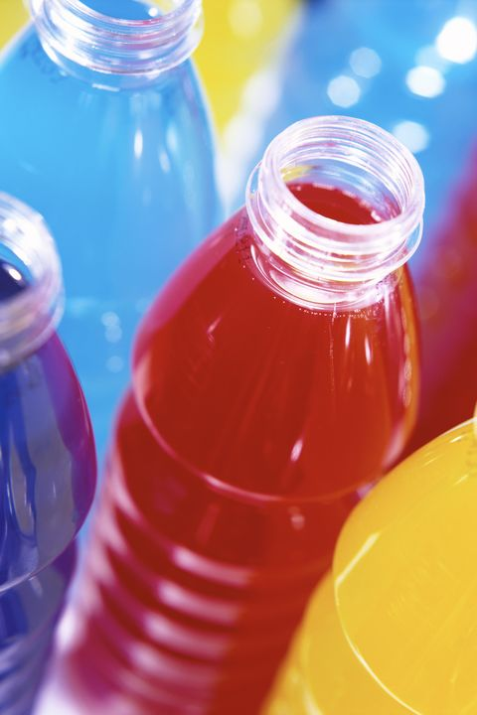
11.Energy Drinks
It's not just the caffeine in energy drinks that makes you wired. Most beverages contain taurine, an amino acid that increases alertness and elevates your heart rate and blood pressure.

